|  |  |
| --- | --- |
| **Ex. 2** | **EXPLORING OPERATORS AND EXPRESSIONS** |
| **Date: 29.01.24** | |
|  | |

**Aim:**

To explore the use of operators and expressions in Python by writing programs for the following and executing them:

1. Get the dimensions (floating point values) of a triangle, parallelogram, cylinder, cone, sphere, and rectangular prism, calculate each of their areas and display the result as a floating-point number approximated to 2 decimal places.
2. Calculate the simple interest and compound interest, given the principal amount (P), rate of interest (R), term of deposit (T) (in years), and number of times interest is compounded in a year (n) from the user. Display the result rounded off to 4 decimal places.
3. Calculate the salary of an employee of a company in terms of the basic pay, dearness allowance (DA), and house rent allowance (HRA). The DA and HRA are set as a certain percentage of the basic pay. Further, the company deducts 12% of the basic pay for PF. Compute the salary that would be received by an employee given the basic pay, percentage of basic pay for DA, and percentage of basic pay for HRA and print it, rounded off to the nearest integer. (Salary = Basic Pay + DA + HRA - PF)
4. Implement the following using functions from the math module and print the results in the scientific notation, approximated to 2 decimal places. Get the values for the variables involved from the user:
$$Acosθ−Bsin\left(θ\right)$$

$$Acos\left(2πn\right)$$

$$e^{an}$$

5. Euclidean distance between two points (x1, x2) and (y1, y2) (Use the formula for Euclidean distance - $\sqrt{{\left(x1−x2\right)}^{2}+{\left(y1−y2\right)}^{2}}$)
6. Convert an angle theta from radians to degrees.
7. Find the base 10 and base 2 logarithm of a floating-point number x.
8. Obtain 2 decimal numbers from the user, display them in binary, octal, and hexadecimal forms, perform the logical operations (and, or, not, left and right shift) and print the results in binary and decimal forms.

f. Find the roots of a quadratic equation of the form ax2+bx+c. Get the values of a, b, and c from the user and display the roots.(Hint: Roots of a quadratic equation are calculated using the formula: −b±b2−4ac√2a Note: Use the cmath library to handle complex numbers.)

**Algorithm:**

**(a)**

Step 1: Get the required inputs for the formula for the area of each shape

Step 2: Evaluate the result using the formula

Step 3: Display the output (area) in floating point values rounded of to the 2nd decimal point

**(b)**

Step 1: Get inputs for the principle amount,time,rate of interest

Step 2: Calculate the SI and CI for the given inputs

Step 3: Display the SI and CI to the user

**(c)**

Step 1: Get Inputs for basic Pay, % of DA and % of HRA

Step 2: Calculate the salary based on the given equation

Step 3: Display the Salary to the user.

**(d)**

Step 1: Get Inputs for the required Variables

Step 2: Evaluate the expressions given with the user inputs

Step 3: Display the answer for every expression.

**(e)**

Step 1: Get the inputs for variable a and b

Step 2: Evaluate the given Conversions and Logical Operations.

Step 3: Display the output to the user

**(f)**

Step 1: Get the inputs for co-efficients of the Quadratic equation

Step 2: Evaluate the the roots using cmath library

Step 3: Display the roots to the user.

**Program:**

**(a)**

# Program to find area of specified Shapes

import math

print("Finding area of Triangle : ")

b = input("\tEnter the Base length of the triangle : ")

h = input("\tEnter the Height of the triangle : ")

print("\t\tThe area is = {:0.2f}".format((0.5 * float(b) * float(h))))

print("Finding area of Parallelogram : ")

b = input("\tEnter the Base length : ")

h = input("\tEnter the Height : ")

print("\t\tThe area is = {:0.2f}".format((float(b) * float(h))))

print("Finding area of Cylinder : ")

r = input("\tEnter the Radius : ")

h = input("\tEnter the Height : ")

print("\t\tThe area is = {:0.2f}".format((2* math.pi * float(r) * (float(r) + float(h)))))

print("Finding area of Cone : ")

r = input("\tEnter the Radius : ")

l = input("\tEnter the Length : ")

print("\t\tThe area is = {:0.2f}".format((math.pi * float(r) * ( float(r) + float(l)))))

print("Finding area of Sphere : ")

r = input("\tEnter the Radius : ")

print("\t\tThe area is = {:0.2f}".format((4 * math.pi * math.pow(float(r),2))))

print("Finding area of Prism : ")

w = float(input("\tEnter the Width : "))

l = float(input("\tEnter the Length : "))

h = float(input("\tEnter the Height : "))

print("\t\tThe area is = {:0.2f}".format((2 * (w*l + h*l + h*w))))

**(b)**

# Program to find Simple and Compound Interest

import math

p = float(input("Enter the Principle Amount : "))

r = float(input("Enter the Rate Of Interest : "))

t = float(input("Enter the Term of Deposit : "))

n = float(input("Enter the Interest Compounds in a year : "))

print("Simple Interest = {:0.4f}".format((p * t * r)/100))

print("Compound Interest = {:0.4f}".format((p * math.pow((1 + r/n),n*t) - p)))

**(c)**

#Calculate Salary of an employee

import math

BP = float(input("Enter the basic Pay : "))

DA = float(input("Enter the Persent of DA: "))

HRA = float(input("Enter the Persent of HRA: "))

print("Salary = {:0.2f}".format(BP + (BP * DA/100) + (BP * HRA/100) - (BP *0.12)))

**(d)**

# Math Functions Usages

import math

print("(i) Acos(theta) - Bsin(theta)")

A = float(input("\tEnter the value for A : "))

B = float(input("\tEnter the value for B : "))

Theta = float(input("\tEnter the value for Theta : "))

print("\t\tAnswer : {:0.2E}".format((A * math.cos(Theta)) - (B * math.sin(Theta))))

print("(ii) Acos(2 pi n)")

A = float(input("\tEnter the value for A : "))

n = float(input("\tEnter the value for n : "))

print("\t\tAnswer : {:0.2E}".format(A * math.cos(2 * math.pi * n)))

print("(iii) e^an")

a = float(input("\tEnter the value for a : "))

n = float(input("\tEnter the value for n : "))

print("\t\tAnswer : {:0.2E}".format(math.exp(a*n)))

print("(iv) euclidian Distance")

x1 = float(input("\tEnter the value for X1 : "))

y1 = float(input("\tEnter the value for Y1 : "))

x2 = float(input("\tEnter the value for X2 : "))

y2 = float(input("\tEnter the value for Y2 : "))

print("\t\tAnswer : {:0.2E}".format(math.sqrt(math.pow(x1-x2,2) + math.pow(y1-y2,2))))

print("(v) degree to radians")

a = float(input("\tEnter the value for theta in degrees : "))

print("\t\tAnswer : {:0.2E}".format(math.radians(a)))

print("(v) log with base 10 and 2")

x = float(input("\tEnter the value for x : "))

print("\t\tAnswer : log base 10 = {:0.2E} | base 2 = {:0.2E}".format(math.log10(x),math.log2(x)))

**(e)**

# Bin,Decimal,Hexasecimal,Octal conversions and logical operations

a = int(input('Enter the value for a : '))

b = int(input('Enter the value for b : '))

print("To Binary\n\ta = {}\n\tb = {}".format(bin(a),bin(b)))

print("To Octal\n\ta = {}\n\tb = {}".format(oct(a),oct(b)))

print("To Hexa\n\ta = {}\n\tb = {}".format(hex(a),hex(b)))

print("And operation :\n\tIn decimal : {}\n\tIn Binary : {}".format(a and b , bin(a and b)))

print("OR operation :\n\tIn decimal : {}\n\tIn Binary : {}".format(a or b , bin(a or b)))

print("Not operation :\n\tFor a : \n\t\tIn decimal : {}\n\t\tIn Binary : {}\n\tFor b : \n\t\tIn decimal : {}\n\t\tIn Binary : {}".format(not a , bin(not a),not b, bin(not b)))

print("Left Shift operation :\n\tIn decimal : {}\n\tIn Binary : {}".format(a << b ,bin(a<<b)))

print("Right Shift operation :\n\tIn decimal : {}\n\tIn Binary : {}".format(a>> b ,bin(a>>b)))

**(f)**

# Finding roots of quadratic equaion

import cmath,math

a = float(input("Enter the value of A : "))

b = float(input("Enter the value of B : "))

c = float(input("Enter the value of C : "))

det = math.pow(b,2) - (4 * a * c)

prev = -b / (2*a)

print("The roots are : {} and {}".format(prev + cmath.sqrt(det)/(2*a),prev - cmath.sqrt(det)/(2*a)))

**Screenshot of Output:**

**(a)**

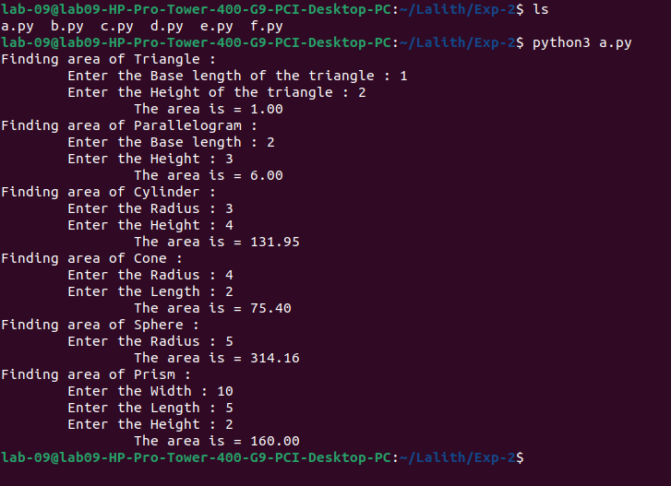

**(b)**

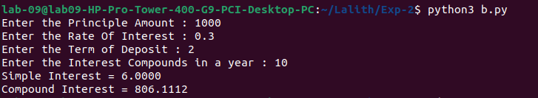

**(c)**

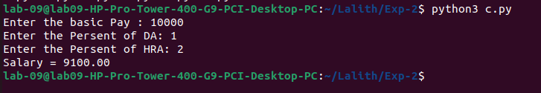

**(d)**

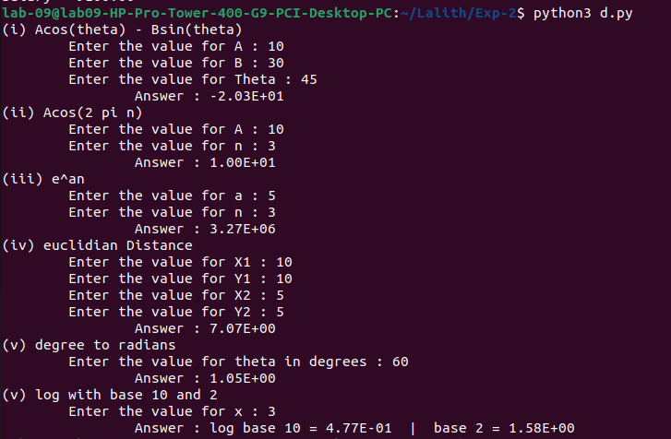

**(e)**

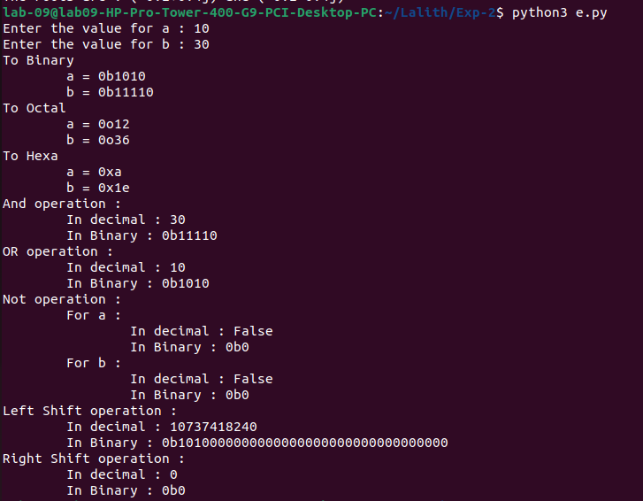

**(f)**

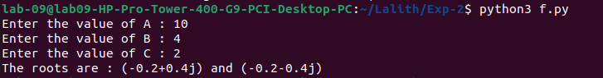

**Result:**

Thus, programs have been written and executed to explore the use of operators and expressions in Python.